Home Page:

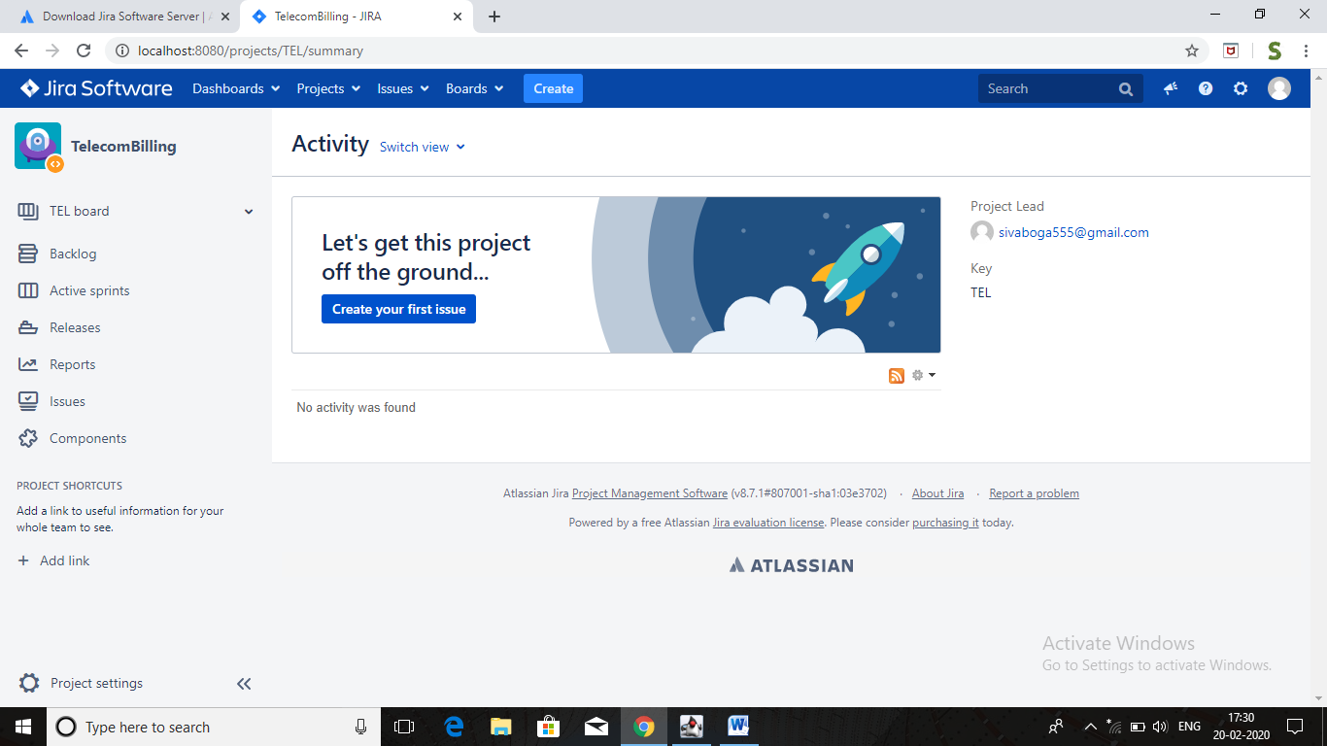

Step 1: Create Project:

Create Project -> Scrum software development -> Select (work flow) -> Enter project name -> Submit.

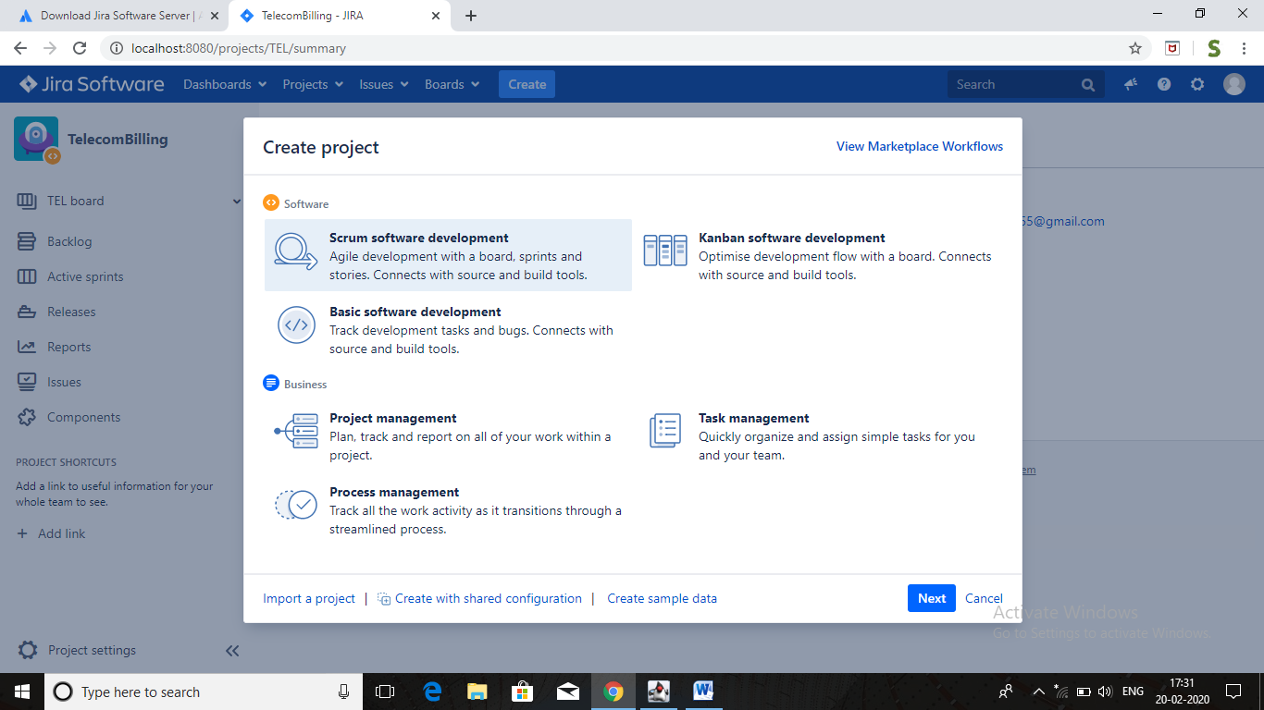

Stet 2: Create Story:

Go to create button -> Select project, Issue type, Summary (Story Name)….. ->Assignee story (whoom) -> Create.

Step 3: Create Sprint

Click on backlog -> click create sprint button -> drag the stories to sprint (create issue) -> then start sprint -> enter how many weeks -> click start.

Click on story inside the sprint (then right side open a small window) -> click on icons (…) -> More actions -> select in progress (which means work has been started).

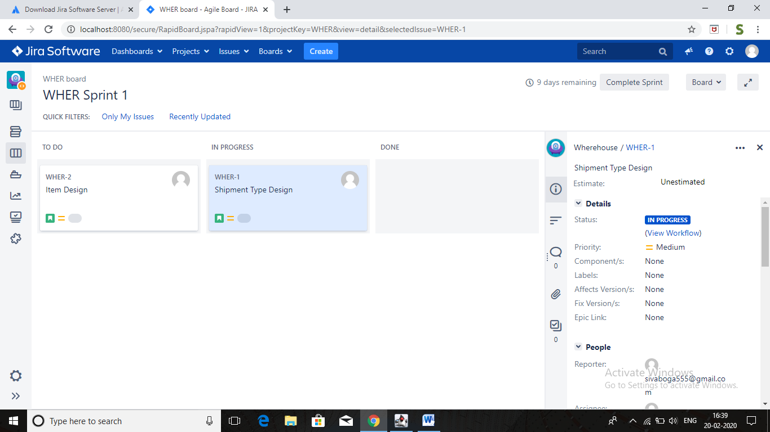

If one story divided multiple sub tasks -> click on story -> click on icons -> select create sub task -> create -> then go to active a sprints -> see two more tasks are added.

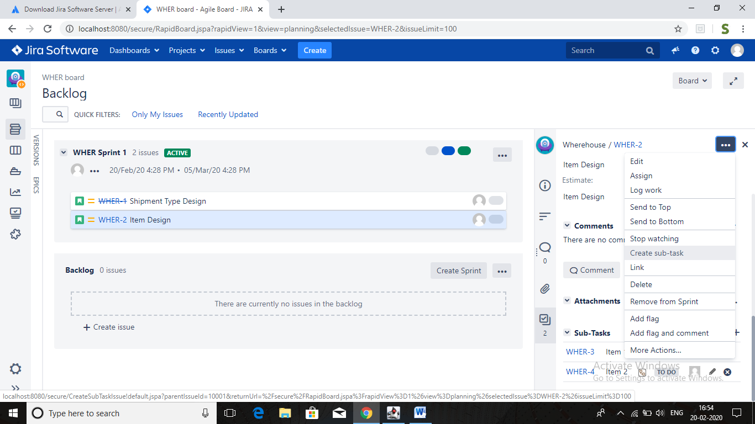

Click on the sub task -> add description -> and write the comments -> here add watchers (when add comment mail will got all the members) -> click on in progress and done (close the ticket).

